Exercise 1 Spring Data JPA Quick Example
Step 1: Create Spring Boot Project
Go to start.spring.io
Select:
· Project: Maven
· Language: Java
· Spring Boot: 3.2.x
· Java: 21
Dependencies:
· Spring Web
· Spring Data JPA
· H2 Database
Step 2: Setup Application properties and add JPA
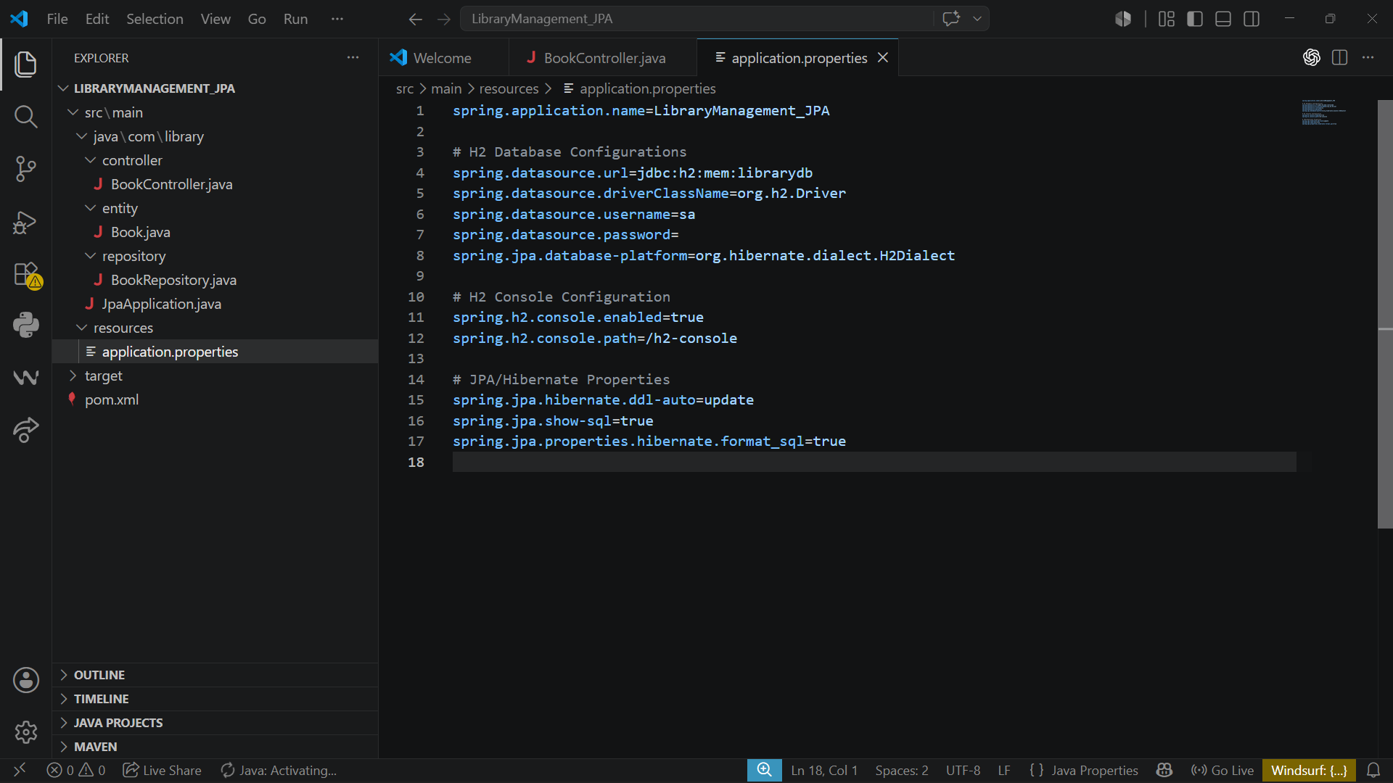

Create the entity and repository for the data and also create the controllers for every endpoint and run the application
Entity: Book.java
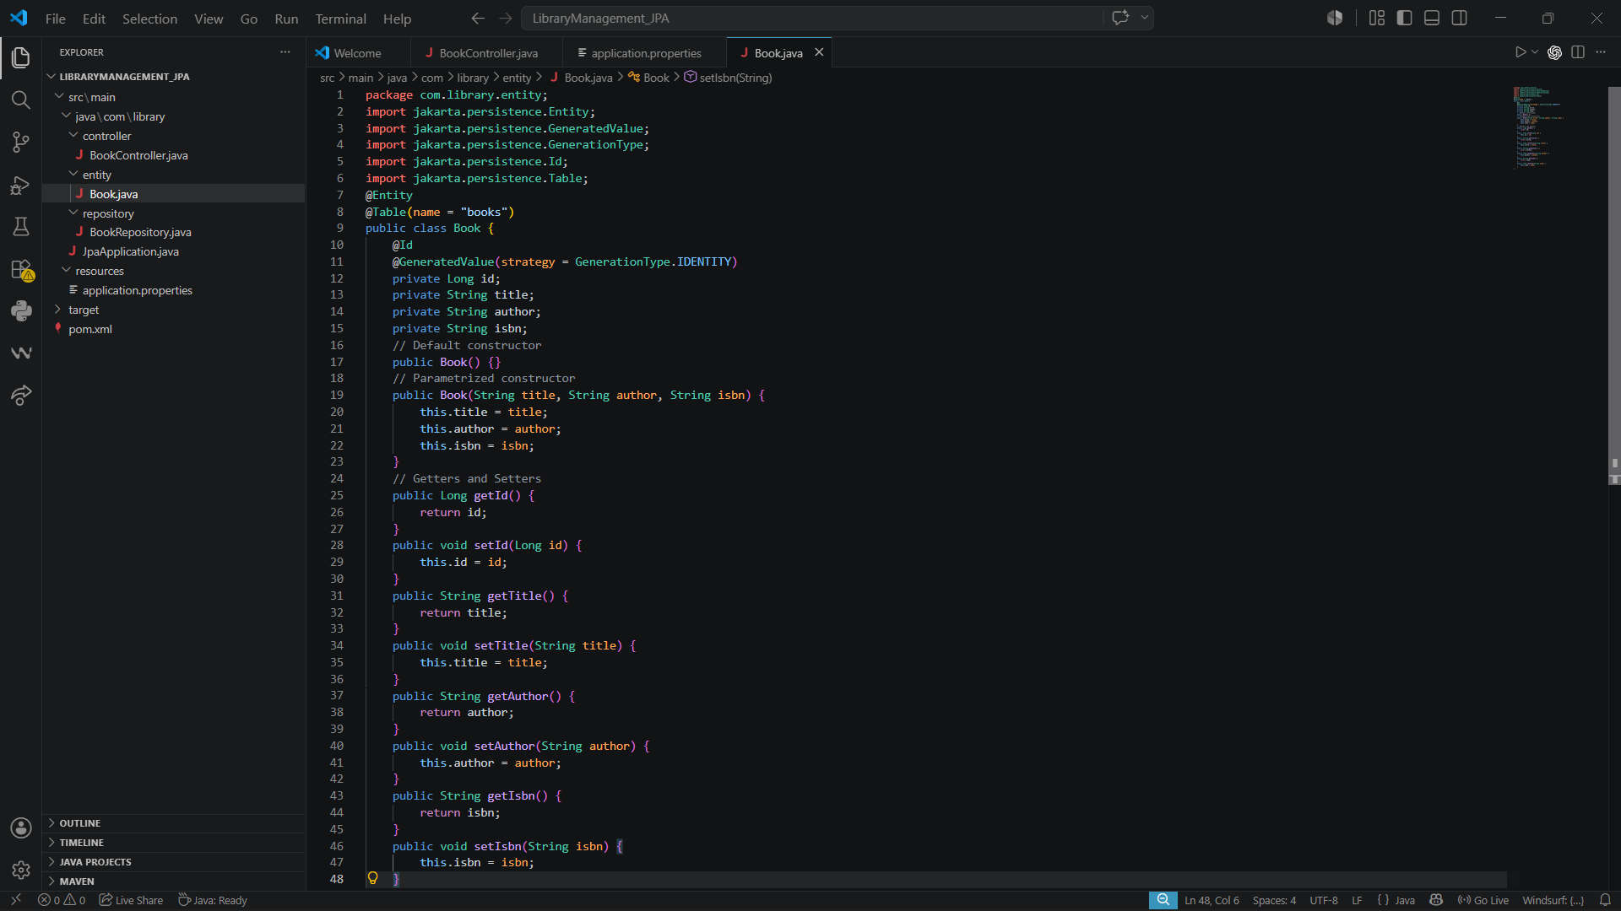
Repository: BookRepository.java
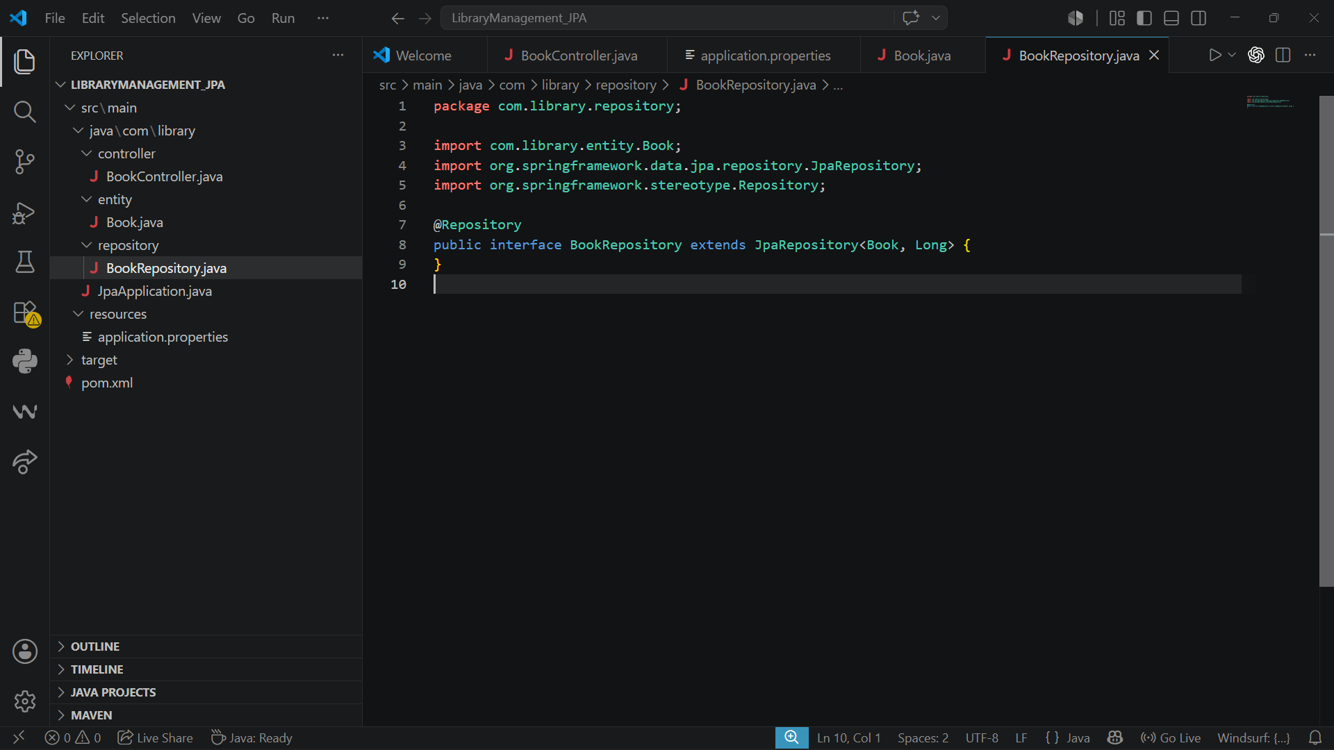

Controllers: BookContoller.java
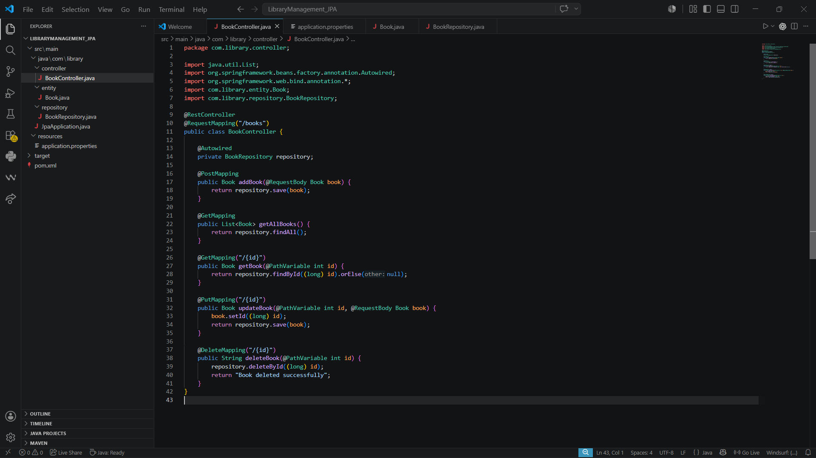
Main class
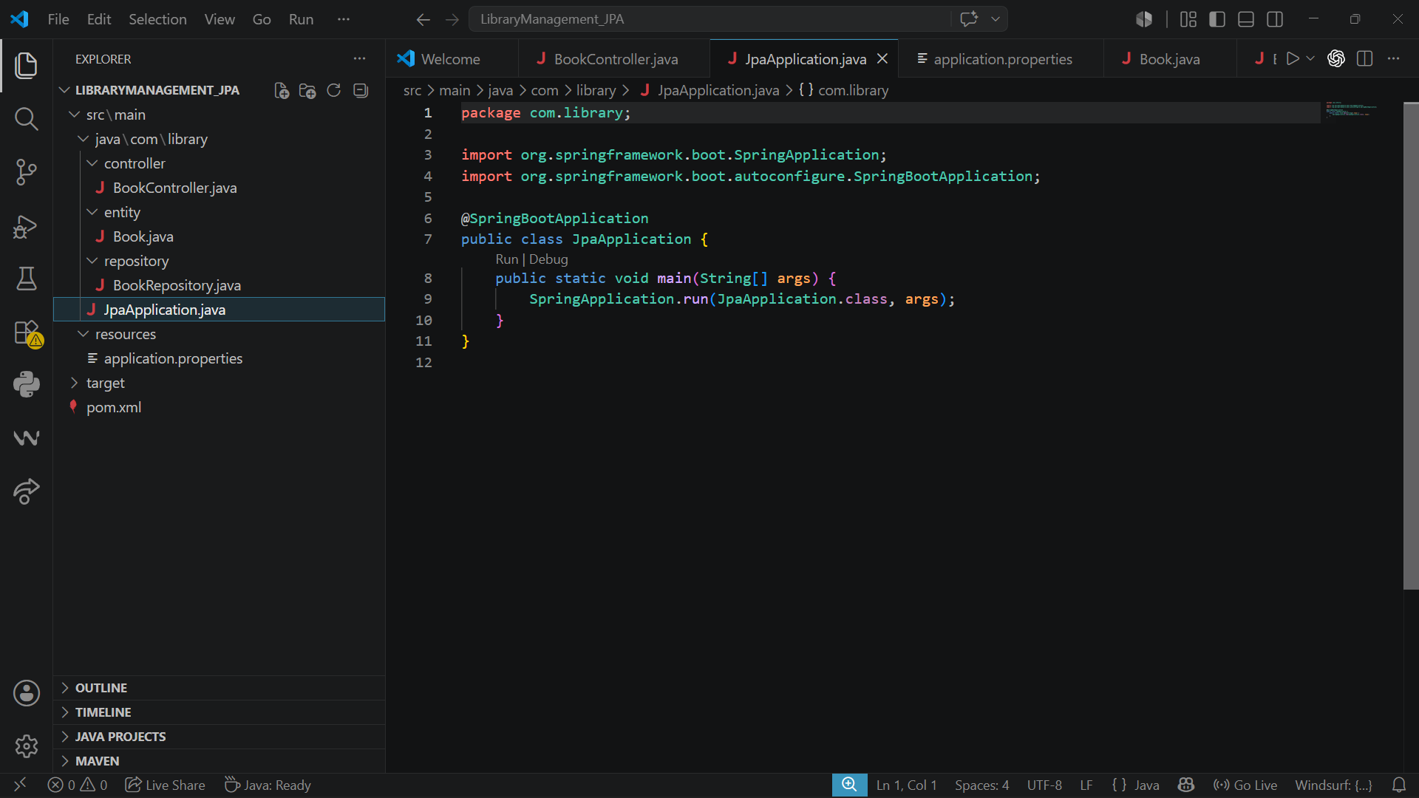

Posting Data:
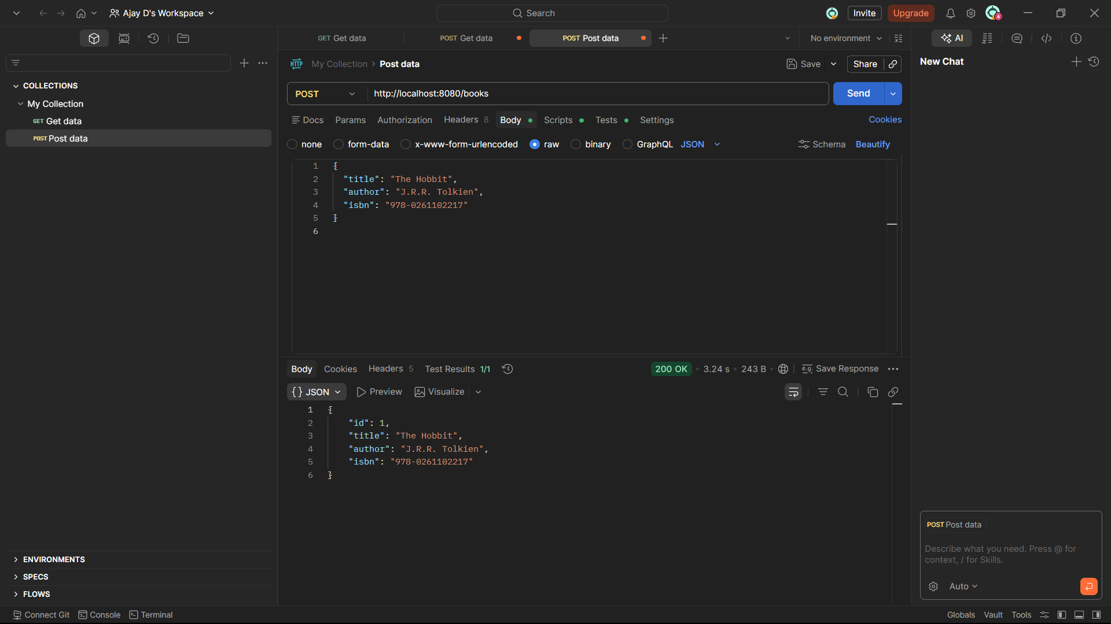
Getting Data
